Live Q&A 4 Transcript

Preliminaries
Lip reading is important! (I thought this would happen to me one day…)
There were some problems with the SGTs last week. Some were cancelled at short notice, etc.. There’s a lot of shuffling going on and it makes it very difficult for us. If you were affected with the problems, first of all, sorry. It’s not that we’re not aware or we’re taking this seriously, it just has been a very difficult situation.
The topic of the SGT will be the material for the previous week. You don’t have to watch the week 4 videos before coming to this week’s session.
Thank you for filling out the feedback! The feedback we’ve gotten is that we’re doing it well! The pace is about right, the material on KEATS and live lectures is helpful.

First assignment
The first assignment is available today. You can download the material now. It’s marked coursework so it contributes to the final module mark. There is a BlueJ project you are expected to download and extend. There’s also a marking scheme or rubric to see what is expected of you.
You have to pay attention to plagiarism. You have to complete this quiz before you can submit the assignment to show that you are aware of the plagiarism rules. You can be penalized for submitting something that isn’t explicitly attributed to someone else.

Itempool Quiz
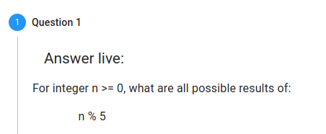

0, 1, 2, 3, 4
- If you did not get C, revise!
- Modulo gives you the remainder.

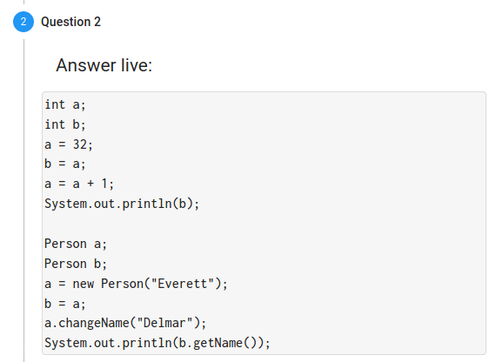

32 Delmar
- Where a gets assigned to Everett, a gets changed and b gets printed out. Most of you assumed changing a will not change b. In this case, this is not correct.
- The memory only stores a reference for object types. So if a gets changed, b will also change.
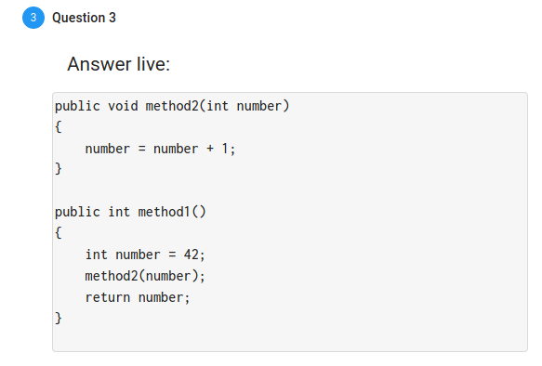

42
- There is no return method!

Questions & Answers

Will the assignment require the knowledge of the week 5 content?
Probably not, but it doesn’t really matter. You will see.

What do we use to detect plagiarism on our codes for the assignment?
Just don’t steal code! We detect your plagiarism, not you! If you use code from somewhere else like StackOverflow, attribute the code in a comment. It is perfectly fine to use class libraries etc., we just expect you to write a substantial part of the assignment of yourself and explicitly attribute it.

I am struggling a lot with PPA. I had no prior programming knowledge coming so it makes it even harder to understand. What do you recommend?
Where you are right now is not surprising. What I recommend is doing the programming exercise. You do not learn to program by listening to me talk to you. The videos are an introduction to the concept, but it is not sufficient. You learn to program only by doing it and doing it repeatedly. It is the repetition that makes it easier.

For plagiarism, are we able to copy that particular part of code and paste it to our code and then tweak it…
If I lock you alone in a closed room, you need to be able to write it and explain it. If you copy and paste it, you have to attribute it. If you get the idea and write it yourself from a learning point of view, then you’re fine. Insert a comment, giving your inspiration.

So I understand how changing a reference doesn’t affect the original object, but would this work the same way for Strings seeing as they are objects in Java?
For strings, it would be highly confusing. If you assign “Michael” to one variable and “Michael” to another variable and change one, it would change the other. It would be weird. So the Java designers have made strings immutable. Strings can not be changed.
So what happens when you want to attach a few letters to a string? It just generates a new string.

I’m struggling with the workload, I’m one week behind and finding it hard to catch up especially now that we have an assignment. What do you recommend?
We expect 10 hours a week. If you put in 10 hours a week, you can keep up. If you are behind now, I am fairly confident to say that you didn’t spend your 10 hours a week. There is no shortcut to putting in the time. There isn’t some magic trick. You can not afford to skip a week.

If we cannot code something and we find how to do it online, how do we avoid plagiarising?
Don’t look up solutions online and copy and paste it!

What if we don’t plagiarise but it happens to match something else?
If you copy one or two lines, that’s fine. Students don’t understand how unique a class is. If you’re a practised programmer, reading a program is like reading a short story. You remember.

Does Java use pass by value or pass by reference for variables?
Java uses pass by value, and only pass by value. C++ has both mechanisms. When you pass object types, you pass the object reference by value. The semantics are different.

After writing one question, I can’t write another one
I’ll change the settings!

Are we supposed to do the challenge tasks? Or only base tasks?
You can invent your own challenge task! If you aim to get a really good mark in this assignment, you should do the challenge tasks or invent your own. Do the base tasks to make sure you’re passing the assignment, then do the challenge tasks.

Do we have to do the challenge tasks to get full marks?
You hardly get ever what you call “full marks” at the university. You will see that typically to get 100% you have to do something so exceptional that your professor can’t do. If you get over 70%, that is a fantastically good mark. You have to get away from the concept of full marks

Discord Highlight of the session
(Join us on Discord! https://discord.gg/qcXmnBx)
